Asia-China-Coin-Spade-Hollow Handle-Sloping shoulder

Hollow handled spade money空首 處理 鏟錢, type 2, sloping shoulder, 400-300 BCE, associated with the Kingdom of Zhou in the Henan area.

The name "sloping shoulder" is somewhat of a misnomer for the shape of the currency as the form can be either sloping shoulder or square shoulder, bit the bas-relief on the obverse and the reverse always has outside lines that are sloping. The inscriptions are usually clear and consist of none (as in the first example below) to one or two characters as in the second example below).

These coins are literally in the shape of farming implements and were used in accordance with specific designs of the Henan area.

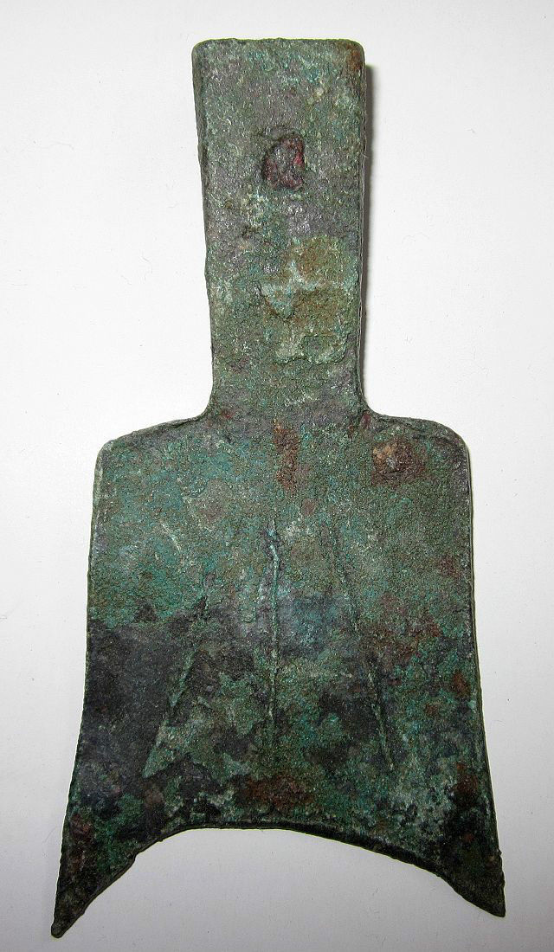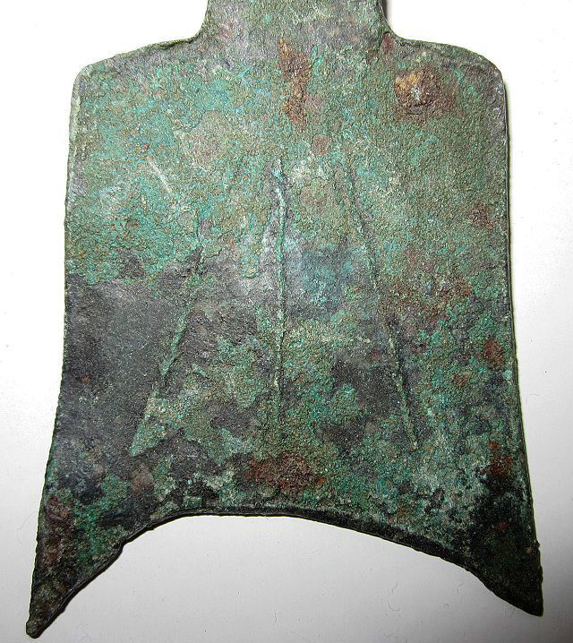

Hollow handled spade money空首 處理 鏟錢, type 2, sloping shoulder, 400-300 BCE, obv., no inscription, outside lines that are sloping , length 9.5 cm. /3.74 in., width 5 cm./1.97 in., Harthill, p. 14, no. 2.160, rarity 5.

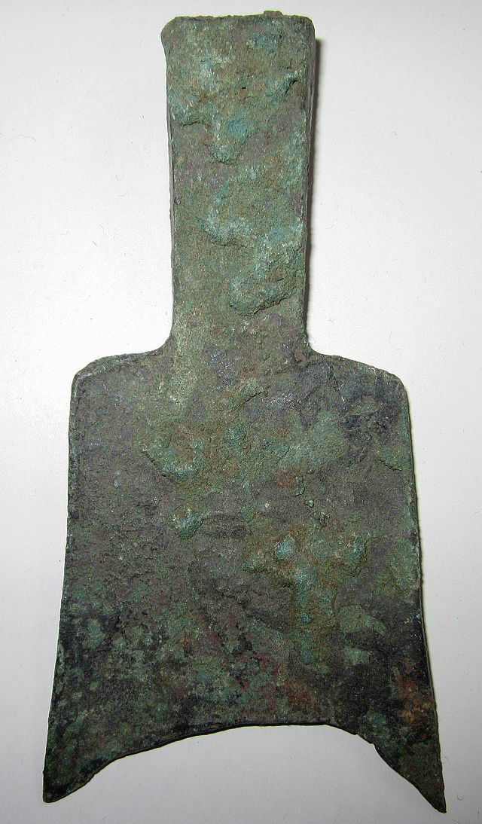

Same reverse. with outside lines that are sloping

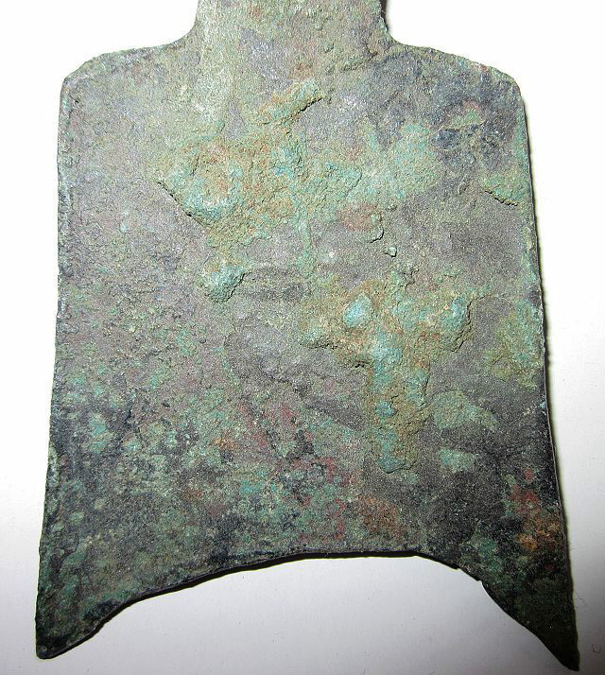

Same reverse. Detail with three lines, 2 sloping.

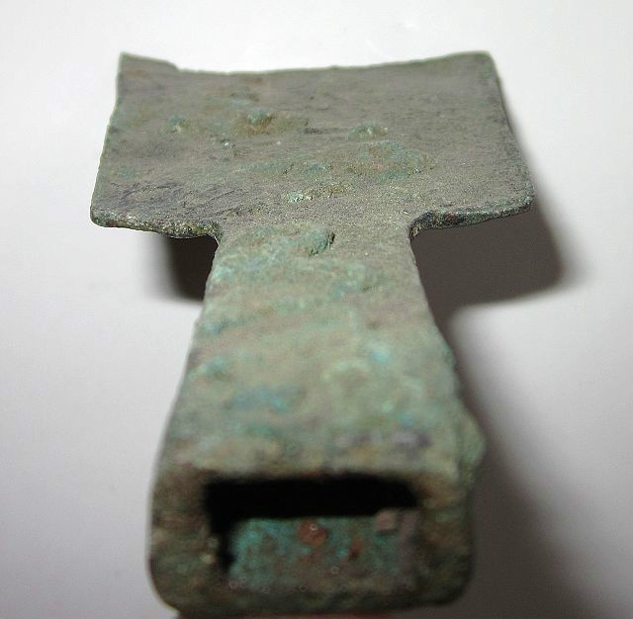 Same showing hollow handle..

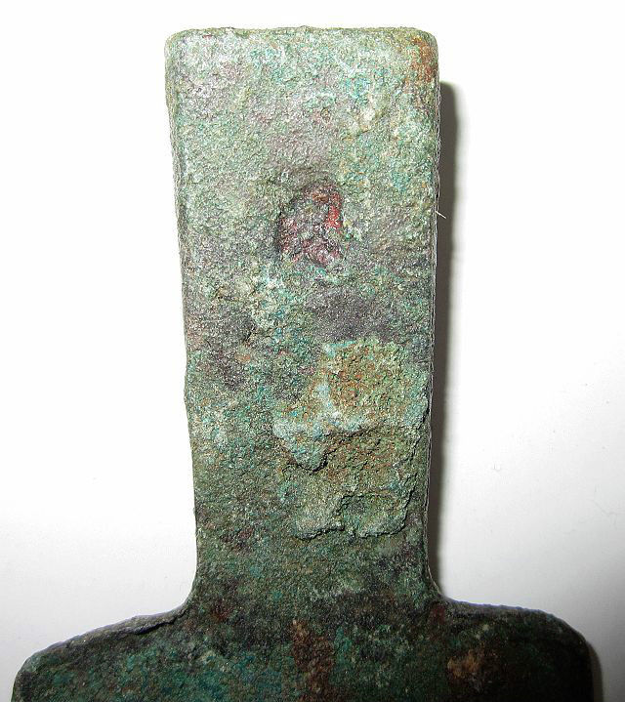

Same , showing imperfectly punctured hole in handle. 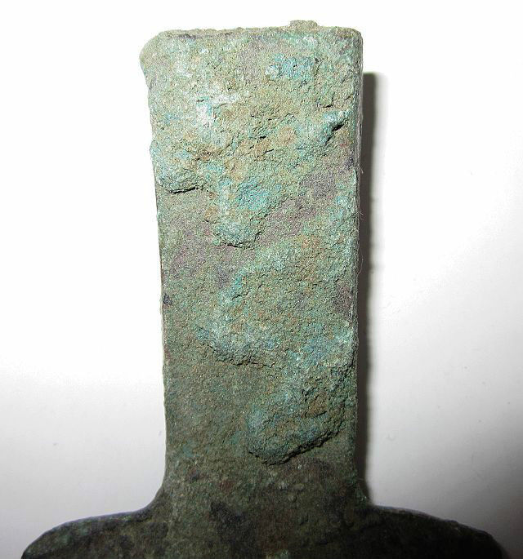

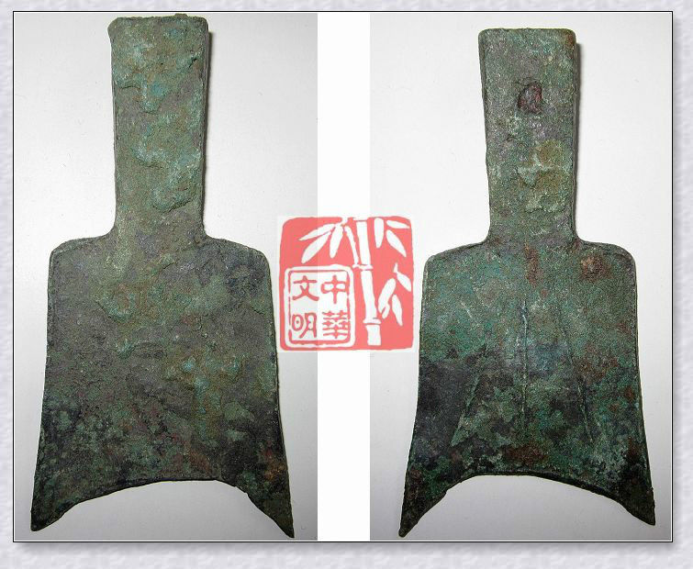

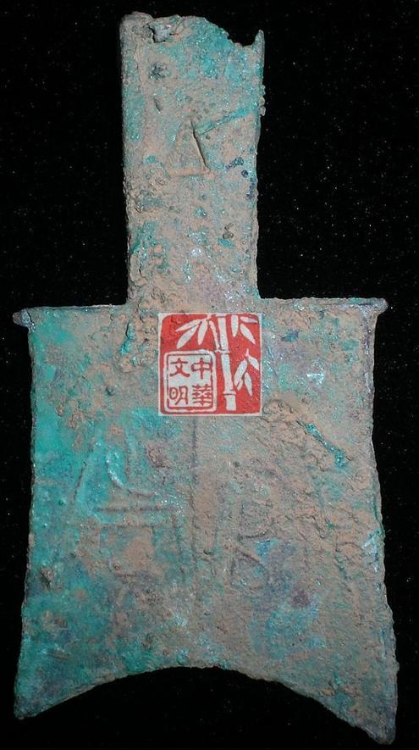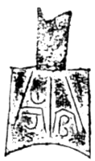

Hollow handled spade money空首 處理 鏟錢, type 2, sloping shoulder, 400-300 BCE., Obv:inscription: 官市, Guαn Shim, or官考,Guαn K!αo. Length 7.6 cm. / 2.99 in., width 3.9 cm., 1.54 in., Harthill 2.165, Rarity 2, References: Fisher and Ding 1990 101, Schjöth [1929] 1976, 41.

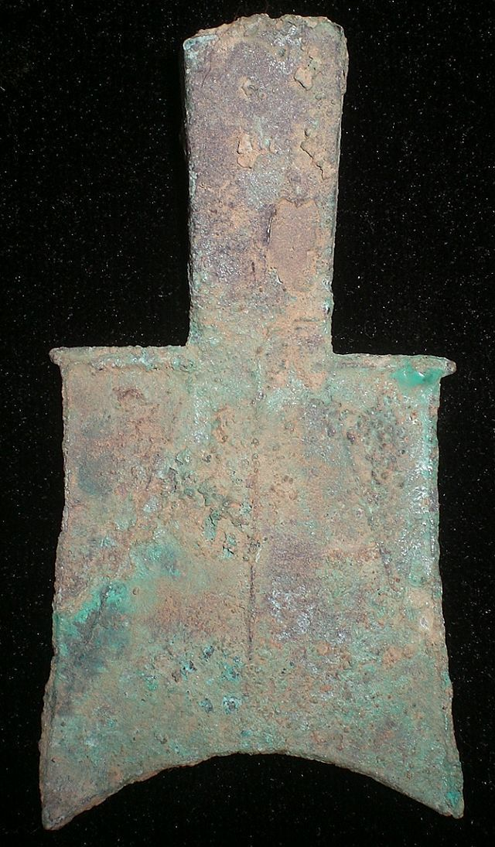

Same reverse, Hollow handled spade money空首 處理 鏟錢, type 2, sloping shoulder, 400-300 BCE., with three lines, 2 sloping. No inscription.

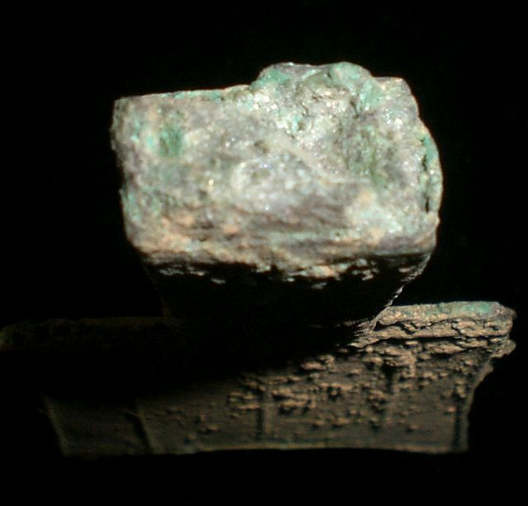

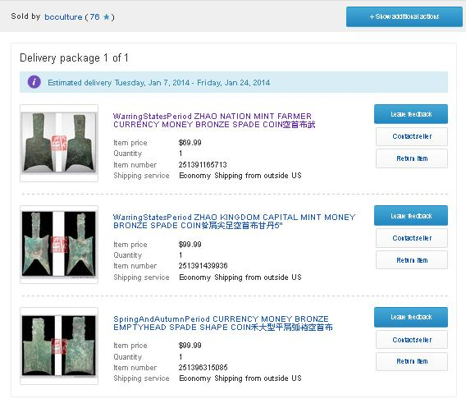 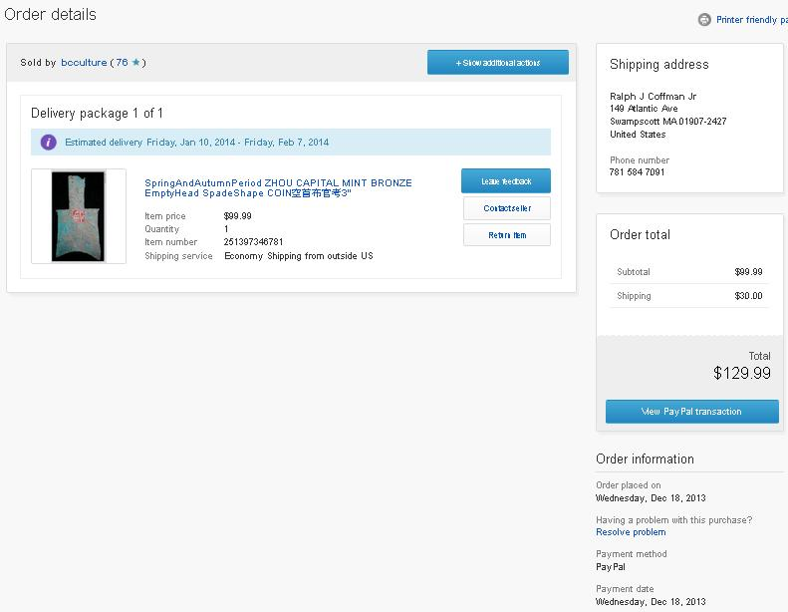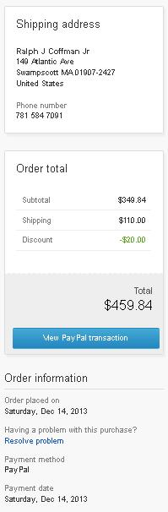

Order information

Order placed on Saturday, Dec 14, 2013

Payment method PayPal  
Payment date Saturday, Dec 14, 2013

Shipping address

Ralph J Coffman Jr

149 Atlantic Ave   
Swampscott MA 01907-2427  
United States

Phone number  
781 584 7091

Item(s) bought from cnrelics

#### Qty

#### Item name

#### Shipping service

#### Item price

1

SHANG ZHOU FISHER RIVER MAN MINT SEASHELL MONEY BRONZE GRIMACE ANTNOSE COIN秦字鬼脸钱 (151183182891)

Economy Shipping from outside US

$9.99

1

WARRING STATES PERIOD CHU NATION CITY MINT MONEY GOLD BRONZE ShellShape COIN金鬼脸钱 (151183833448)

Economy Shipping from outside US

$9.99

1

WarringStatesPeriod ZHAO NATION MINT SEAL LIN MONEY BRONZE ROUND COIN蔺圜钱1.5"RARE (151183844968)

Economy Shipping from outside US

$49.99

Item(s) bought from linzhoulin

#### Qty

#### Item name

#### Shipping service

#### Item price

1

CHINA "SHELL" Cash Coin 053130 (161171112357)

Economy Shipping from outside US

$9.90

Item(s) bought from bcculture

#### Qty

#### Item name

#### Shipping service

#### Item price

1

WarringStatesPeriod ZHAO NATION MINT FARMER CURRENCY MONEY BRONZE SPADE COIN空首布武 (251391165713)

Economy Shipping from outside US

$69.99

1

WarringStatesPeriod ZHAO KINGDOM CAPITAL MINT MONEY BRONZE SPADE COIN耸肩尖足空首布甘丹5" (251391439936)

Economy Shipping from outside US

$99.99

1

SpringAndAutumnPeriod CURRENCY MONEY BRONZE EMPTYHEAD SPADE SHAPE COIN禾大型平肩弧裆空首布 (251396315085)

Economy Shipping from outside US

$99.99

Order total

Subtotal

Shipping

Discount

Total

$349.84

$110.00

-$20.00

$459.84